88 Claremont Road, Bernardsville, NJ 07924
Sixteenth Sunday after Pentecost
September 25, 2022

10:00 a.m. Holy Eucharist

Welcome to St. Bernard’s Episcopal Church. Thank you for sharing in our worship today. This week we welcome Henry Gehman as our guest organist. Together we are learning new service music written by our Director of Music.

PRELUDE Rhosymedre by Ralph Vaughan Williams
PROCESSIONAL HYMN 428 O all ye works of God, now come
1 | O all ye works of God, now come  to thank him and adore;  O angels, sing and bless the Lord  and praise him evermore. | 2 | O sun and moon and stars of heaven,  your endless praise outpour;  O changing seasons, bless the Lord  and praise him evermore.
3 | O heat and cold, O night and day,  O storms and thunder’s roar,  O fields and forests, bless the Lord  and praise him evermore. | 4 | O earth and sea, O all that live  in water or on shore,  O men and women, bless the Lord  and praise him evermore.
5 | O let his people bless the Lord  like righteous souls of yore;  let those of holy, humble heart  come praise him evermore. | 6 | So let us glorify and bless  the God we bow before,  the Father, Holy Spirit, Son,  and praise him evermore.

OPENING ACCLAMATION BCP p. 355
Celebrant Blessed be God: Father, Son, and Holy Spirit.
People And blessed be God’s kingdom, now and forever. Amen.
COLLECT FOR PURITY BCP p. 355
Let us pray. Almighty God, to you all hearts are open, all desires known, and from you no secrets are hid: Cleanse the thoughts of our hearts by the inspiration of your Holy Spirit, that we may perfectly love you, and worthily magnify your holy Name; through Christ our Lord. Amen.
GLORIA St. Bernard’s Service

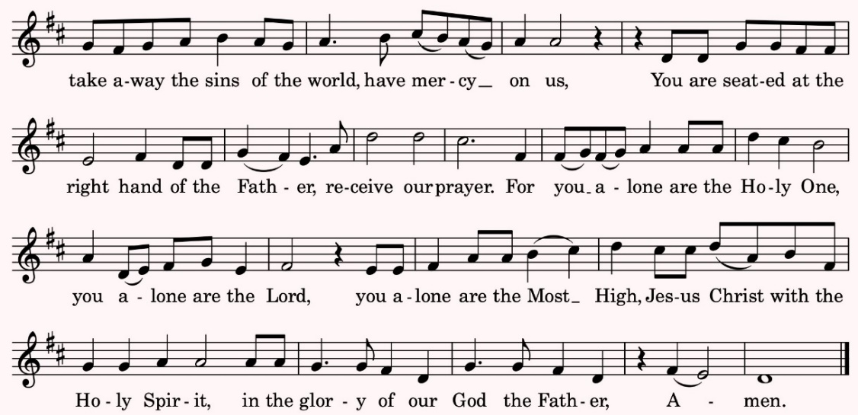

THE COLLECT OF THE DAY BCP p. 234
Celebrant The Lord be with you. People And also with you.

Let us pray. O God, you declare your almighty power chiefly in showing mercy and pity: Grant us the fullness of your grace, that we, running to obtain your promises, may become partakers of your heavenly treasure; through Jesus Christ our Lord, who lives and reigns with you and the Holy Spirit, one God, for ever and ever. Amen.

FIRST READING: Amos 6:1a, 4-7 Michele Esposito-Edwards in church

Lector A Reading from the Book of Amos.
Alas for those who are at ease in Zion, and for those who feel secure on Mount Samaria. Alas for those who lie on beds of ivory, and lounge on their couches, and eat lambs from the flock,
and calves from the stall; who sing idle songs to the sound of the harp, and like David improvise on instruments of music; who drink wine from bowls, and anoint themselves with the finest oils, but are not grieved over the ruin of Joseph! Therefore they shall now be the first to go into exile, and the revelry of the loungers shall pass away.

Lector The Word of the Lord. People Thanks be to God.
PSALM 146 said responsively, by the half verse Michele Esposito-Edwards in church BCP p. 803

1 Hallelujah! Praise the Lord, O my soul! * I will praise the Lord as long as I live; I will sing praises to my God while I have my being.
2 Put not your trust in rulers, nor in any child of earth, * for there is no help in them.
3 When they breathe their last, they return to earth, * and in that day their thoughts perish.
4 Happy are they who have the God of Jacob for their help! * whose hope is in the Lord their God;
5 Who made heaven and earth, the seas, and all that is in them; * whose promise abides for ever;
6 Who gives justice to those who are oppressed, * and food to those who hunger.
7 The Lord sets the prisoners free; the Lord opens the eyes of the blind; * the Lord lifts up those who are bowed down;
8 The Lord loves the righteous; the Lord cares for the stranger; * the Lord sustains the orphan and widow, but frustrates the way of the wicked.
9 The Lord shall reign for ever, * your God, O Zion, throughout all generations. Hallelujah!

SECOND READING: 1 Timothy 6:6-19 Julia Somers in church

Lector A Reading from the First Letter of Paul to Timothy.
There is great gain in godliness combined with contentment; for we brought nothing into the world, so that we can take nothing out of it; but if we have food and clothing, we will be content with these. But those who want to be rich fall into temptation and are trapped by many senseless and harmful desires that plunge people into ruin and destruction. For the love of money is a root of all kinds of evil, and in their eagerness to be rich some have wandered away from the faith and pierced themselves with many pains. But as for you, man of God, shun all this; pursue righteousness, godliness, faith, love, endurance, gentleness. Fight the good fight of the faith; take hold of the eternal life, to which you were called and for which you made the good confession in the presence of many witnesses. In the presence of God, who gives life to all things, and of Christ Jesus, who in his testimony before Pontius Pilate made the good confession, I charge you to keep the commandment without spot or blame until the manifestation of our Lord Jesus Christ, which he will bring about at the right time-- he who is the blessed and only Sovereign, the King of kings and Lord of lords. It is he alone who has immortality and dwells in unapproachable light, whom no one has ever seen or can see; to him be honor and eternal dominion. Amen.
As for those who in the present age are rich, command them not to be haughty, or to set their hopes on the uncertainty of riches, but rather on God who richly provides us with everything for our enjoyment. They are to do good, to be rich in good works, generous, and ready to share, thus storing up for themselves the treasure of a good foundation for the future, so that they may take hold of the life that really is life.

Lector The Word of the Lord. People Thanks be to God.
GRADUAL HYMN 552 Fight the good fight
1 | Fight the good fight with all thy might,  Christ is thy strength and Christ thy right;  lay hold on life, and it shall be  thy joy and crown eternally. | 2 | Run the straight race through God’s good grace,  lift up thine eyes and seek his face;  life with its way before us lies,  Christ is the path and Christ the prize.
3 | Cast care aside, lean on thy Guide;  his boundless mercy will provide;  trust, and thy trusting soul shall prove  Christ is its life and Christ its love. | 4 | Faint not nor fear, his arms are near;  he changeth not, and thou art dear;  only believe, and thou shalt see  that Christ is all in all to thee.

THE HOLY GOSPEL: Luke 16:19-31 The people remain standing for the Gospel.
Celebrant The Holy Gospel of our Lord Jesus Christ according to Luke.
People Glory to you, Lord Christ.
We encourage you to listen to the Gospel. To read along, the Gospel can be found in the pew Bible on p. 909-910.
Celebrant The Gospel of the Lord.
People Praise to you, Lord Christ.
THE SERMON The Rev. Beth Rauen Sciaino
NICENE CREED BCP p. 358
We believe in one God, the Father, the Almighty, maker of heaven and earth, of all that is, seen and unseen. We believe in one Lord, Jesus Christ, the only Son of God, eternally begotten of the Father, God from God, Light from Light, true God from true God, begotten, not made, of one Being with the Father. Through him all things were made. For us and for our salvation he came down from heaven: by the power of the Holy Spirit he became incarnate from the Virgin Mary, and was made man. For our sake he was crucified under Pontius Pilate; he suffered death and was buried. On the third day he rose again in accordance with the Scriptures; he ascended into heaven and is seated at the right hand of the Father. He will come again in glory to judge the living and the dead, and his kingdom will have no end. We believe in the Holy Spirit, the Lord, the giver of life, who proceeds from the Father and the Son. With the Father and the Son he is worshiped and glorified. He has spoken through the Prophets. We believe in one holy catholic and apostolic Church. We acknowledge one baptism for the forgiveness of sins. We look for the resurrection of the dead, and the life of the world to come. Amen.
THE PRAYERS OF THE PEOPLE Paul Edwards in church Form VI, BCP p. 392
Leader In peace, we pray to you, Lord God. Silence
Leader For all people in their daily life and work;
People For our families, friends, and neighbors, and for those who are alone.
Leader For this community, the nation, and the world;
People For all who work for justice, freedom, and peace.
Leader For the just and proper use of your creation;
People For the victims of hunger, fear, injustice, and oppression.
Leader For all who are in danger, sorrow, or any kind of trouble;
People For those who minister to the sick, the friendless, and the needy.
Leader For the peace and unity of the Church of God;
People For all who proclaim the Gospel, and all who seek the Truth.
Leader For Michael our Presiding Bishop, and William our Bishop; and for all bishops and
other ministers;
People For all who serve God in God’s Church.
Leader For the special needs and concerns of this congregation. We pray for all on our
Prayer List: (read names). After which, the People may add their own petitions.
Leader Hear us, Lord;
People For your mercy is great.
Leader We thank you, Lord, for all the blessings of this life. Silence
The People may add their own thanksgivings.
Leader We will exalt you, O God our King;
People And praise your Name for ever and ever.
Leader We pray for all who have died, that they may have a place in your eternal kingdom.
Silence. The People may add their own petitions.
Leader Lord, let your loving-kindness be upon them;
People Who put their trust in you.
Leader We pray to you also for the forgiveness of our sins. Silence may be kept.
Leader and People Have mercy upon us, most merciful God;
in your compassion forgive us our sins,
known and unknown, / things done and left undone;
and so uphold us by your Spirit
that we may live and serve you in newness of life,
to the honor and glory of your Name; / through Jesus Christ our Lord. Amen.
The Celebrant concludes with an absolution or a suitable collect.
THE PEACE
Celebrant The peace of the Lord be always with you.
People And also with you.
WELCOME AND Announcements
THE HOLY COMMUNION
During the Offertory Solo an offering is collected for God’s mission and ministry.
Thank you for your generosity.

OFFERTORY SOLO Show Me your Ways, O Lord Stephen Pearson

PRESENTATION OF THE GIFTS Old 100th
Praise God from whom all blessings flow, Praise God all creatures here below,
Praise God for all that love has done, Creator, Christ, and Spirit, One.
THE GREAT THANKSGIVING Eucharistic Prayer I, Scottish Liturgy 1982, Scottish Episcopal Church
Celebrant The Lord be with you.
People And also with you.
Celebrant Lift up your hearts.
People We lift them to the Lord.
Celebrant Let us give thanks to the Lord our God.
People It is right to give God thanks and praise.
Worship and praise belong to you, Almighty God, in every place and at all times. All power is yours. You created the heavens and established the earth; you sustain in being all that is. In Christ your Son our life and yours are brought together in a wonderful exchange. Jesus the Christ made his home among us that we might forever dwell in you. Through your Holy Spirit you call us to new birth in a creation restored by love. As children of your redeeming purpose we offer you our praise, with angels and archangels and the whole company of heaven, singing the hymn of your unending glory:
SANCTUS AND BENEDICTUS St. Bernard’s Service
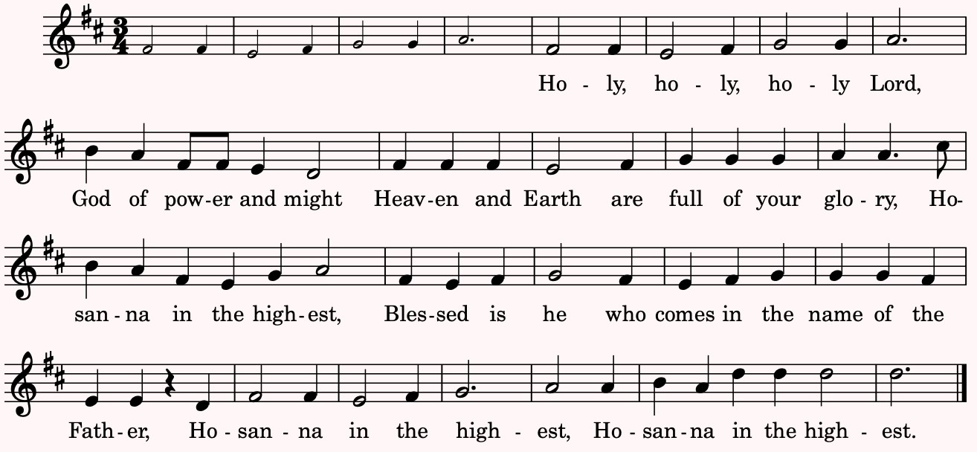

Glory and thanksgiving be to you, most loving Father, for the gift of your Son born in human flesh. Jesus Christ is the Word existing beyond time, both source and final purpose, bringing to wholeness all that is made. Obedient to your will he died upon the cross. By your power you raised him from the dead. Jesus broke the bonds of evil and set your people free to be his Body in the world. On the night when he was given up to death, knowing that his hour had come, having loved his own, he loved them to the end. At supper with his disciples Jesus took bread and offered you thanks. He broke the bread, and gave it to them, saying: “Take, eat. This is my Body: it is broken for you.” After supper, Jesus took the cup, he offered you thanks, and gave it to them saying: “Drink this, all of you. This is my Blood of the new covenant; it is poured out for you, and for all, that sins may be forgiven. Do this in remembrance of me.”
Therefore we proclaim the mystery of faith:
Christ has died. Christ is risen. Christ will come again.
We recall Jesus Christ’s blessed passion and death, his glorious resurrection and ascension; and we look for the coming of Christ’s Kingdom. Made one with Christ, we offer you these gifts and with them ourselves, a single, holy, living sacrifice. Hear us, most merciful God, and send your Holy Spirit upon us and upon this bread and this wine, that, overshadowed by life-giving power, they may be the Body and Blood of your Son, and we may be kindled with the fire of your love and renewed for the service of your Kingdom. Help us, who are baptized into the fellowship of Christ’s Body to live and work to your praise and glory; may we grow together in unity and love until at last, in your new creation, we enter into our heritage in the company of the apostles and prophets, and of all our siblings in Christ, living and departed. Through Jesus Christ our Lord, with whom, and in whom, in the unity of the Holy Spirit, all honor and glory be to you, Lord of all ages, world without end. AMEN.
THE LORD’S PRAYER BCP p. 364
Celebrant And now, as our Savior Christ has taught us, we are bold to say,
Our Father, who art in heaven, hallowed be thy Name, thy kingdom come, thy will be done, on earth as it is in heaven. Give us this day our daily bread. And forgive us our trespasses, as we forgive those who trespass against us. And lead us not into temptation, but deliver us from evil. For thine is the kingdom, and the power, and the glory, for ever and ever. Amen.
THE BREAKING OF THE BREAD The Celebrant breaks the consecrated Bread. Silence is kept.
FRACTION ANTHEM St. Bernard’s Service

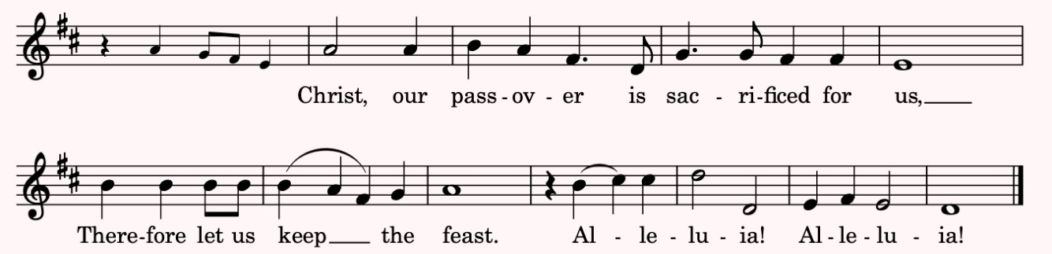

INVITATION TO COMMUNION
Celebrant The Gifts of God for the People of God. Come and meet the Risen Christ.
All are welcome to receive the real and living presence of the Body and Blood of Christ, coming forward and kneeling or standing at the altar rail. For those who choose to receive the Blood of Christ, there are two chalices: the pottery chalice held by the priest is for intincting (dipping), the silver chalice is for those who wish to sip. Gluten-free hosts are available. You may also come forward for a blessing in lieu of Communion.
POST COMMUNION PRAYER Enriching our Worship 1, p. 69
Celebrant Let us stand and pray.
God of abundance, / you have fed us / with the bread of life and cup of salvation;
you have united us / with Christ and one another;
and you have made us one / with all your people in heaven and on earth.
Now send us forth / in the power of your Spirit,
that we may proclaim your redeeming love to the world
and continue for ever / in the risen life of Christ our Savior. Amen.
THE BLESSING
RECESSIONAL HYMN 438 Tell out, my soul
1 | Tell out, my soul, the greatness of the Lord!  Unnumbered blessings give my spirit voice;  tender to me the promise of his word;  in God my Savior shall my heart rejoice. | 2 | Tell out, my soul, the greatness of his Name!  Make known his might, the deeds his arm has done;  his mercy sure, from age the same;  his holy Name—the Lord, the Mighty One.
3 | Tell out, my soul, the greatness of his might!  Powers and dominions lay their glory by.  Proud hearts and stubborn wills are put to flight,  the hungry fed, the humble lifted high. | 4 | Tell out, my soul, the glories of his word!  Firm is his promise, and his mercy sure.  Tell out, my soul, the greatness of the Lord  to children’s children and for evermore!

THE DISMISSAL
Celebrant Go in peace to love and serve the Lord. Alleluia, alleluia!
People Thanks be to God. Alleluia, alleluia!
POSTLUDE In Christ there is no East or West arr. Dale Wood

ASSISTING TODAY AT OUR SERVICE  Celebrant & Preacher The Rev. Beth Rauen Sciaino  Guest Organist Henry Gehman  Soloist Devin McGuire  Lectors Michele Esposito Edwards, Paul Edwards, Julia Somers  Usher Paul Edwards | St. Bernard’s Wardens and Vestry  Christopher Thomas, Paul Edwards, Wardens  Michael Myers, Treasurer; Linda Engleby, Clerk  Thomas Brooks, Zach Conway, Linda Engleby,  Anne Fritts, Beth Gustafson, Taylor Hwong,  Mary Kempen, Jennifer Moss, Michael Myers, Sue Smith
ANNOUNCEMENTS ▪ September 25, 2022
COMMUNITY AND WORSHIP

Coffee Hour & HONEY SALE today after worship, September 25
Join us for Coffee hour this morning after worship, hosted by Cathy Ferrara. All are welcome! We will continue to have coffee hour each Sunday when hosts are available. A sign-up sheet is available for people to sign up and partner with each other. Thank you for helping provide an opportunity for fellowship. The Honey Sale is back! Jars of Ross Farm honey will be available to purchase at our Coffee Hour after worship today. A $20 donation per jar will go to support God's Giving Garden.

Zoom Evening Prayer on Wednesday at 5:30 pm: Sept. 28, Oct. 12, Oct. 26
Evening Prayer is held every other Wednesday at 5:30 pm on Zoom. This fall we are partnering with the Rev’d Danielle Baker and St. Paul’s, Morris Plains. Feel free to listen in on your commute or walking your dog. The liturgy will be on slides, so you can just show up on Zoom. If you do want to review or print resources, they will be available via email and on our website. www.stbernardsnj.org/worship-services-via-zoom Zoom Evening Prayer also serves as a good midweek check-in with each other. All are welcome!

Pastoral Visit
If you or your family or friend would like a visit or conversation, please contact Pastor Beth at priest@stbernardsnj.org or 908-766-0602.
BLESSING OF THE ANIMALS
for the Feast of St. Francis
SEND IN PHOTOS OF YOUR PETS!

Sunday, Oct. 2, at 10 am, in-person or on Zoom
Bring your pet to church to be blessed and/or send photos of your pet(s), with their name(s), into Alison,
Parish Administrator, for our slideshow! We will also remember pets who have died, so you are welcome to send in names or photos of past pets to be remembered. Email: Admin@StBernardsNJ.org

St. Bernard’s Social! Join us at Bistro 73, Bernardsville on Oct 20, 7 pm
Join us for a social evening of fellowship at Bistro 73 in Bernardsville on the evening of Thurs. October 20, at 7 pm. We will likely have a fixed price menu of $45 and the restaurant is BYOB! If you’d like to attend email: Paul Edwards @ paul.edwards0966@gmail.com or Michelle Esposito Edwards @ micheleesposito2011@gmail.com to get your name on the list! All welcome.

CHRISTIAN FORMATION

Scripture as Art TODAY! Sun. Sept 25 at 12 pm via Zoom Sunday link

Join us today for Scripture as Art at 12 pm via Zoom. The scripture for this month’s creative response is Luke 24:13-35, the Road to Emmaus. There’s a lot of moments in this story to creatively enter into reflection. This experience is about the process not the product! All are welcome.

Guided book reflection resumes Thurs., Sept 29, 7-8 pm via Zoom: The Heart of Christianity by Marcus Borg. Session 2: Faith: The Way of the Heart Our next guided book reflection session will be on Thurs., Sept. 29, from 7-8 pm via Zoom. The book is Marcus Borg’s The Heart of Christianity: Rediscovering a Life of Faith. The parish office has a few copies available for $12 each, please contact Alison Davidson, admin@StBernardsNJ.org. Please read Chap. 2, pp 25-42 for the next session on Sept. 29. Each stand-alone session will offer us opportunities to reflect on Christian tradition and our own faith using the author’s guide. Upcoming dates: Sept. 29, Oct. 13, Oct. 27, Nov. 3, Nov. 17.

Bible 101 returning October 9, 12-1 pm via Zoom
Bible 101, led by Al Hudgins, will return on Sun., Oct. 9, at 12 pm via Zoom. The sessions will be held on the second Sunday of each month through December. Upcoming dates include: Oct 9, Nov. 13, and Dec. 11. More details and the topics will be announced soon.
OUTREACH
Food Bank Drive
We welcome your food donations for the Food Bank Network of Somerset County. Thank you for helping our neighbors who are food insecure right now. Suggestions: Rice, canned pasta sauce, fruit & vegetables, shelf stable milk, juice, tuna, canned meat, cereal (hot/cold), mac & cheese, soup, toiletries & paper goods. The Feeding America BackPack program welcomes individual servings because they package food for children to take home for each weekend during the school year. Drop off in the recycling bin outside of the church. Please help to spread the word. Thank you!

Support Pastor Beth at the 8th Annual Rally for Cross Roads, Sat, Oct. 1
Thank you all for your generous past support of this annual fundraiser for Cross Roads Camp and Retreat Center, a vital resource for Episcopalians, Lutherans, and many more in NJ. Last year, this event raised $17,000 and Pastor Beth was one of the top fundraisers for the second year in a row due to your generosity. She will be walking the 5K at Camp again this year. For the 2022 event, Cross Roads is combining the run/walk with lunch and an afternoon of activities, including a volleyball game. You can participate or cheer on others on-site at Cross Roads for part or all of the day on Saturday, Oct. 1 or do the 2K or 5K in your own neighborhood. To donate: https://rallyforcrossroads.itsyourrace.com/donate/BETHSCIAINO-2889535.
GOD’S GIVING GARDEN
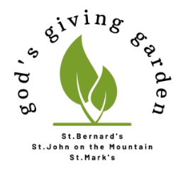
NEWS FROM THE GARDEN

This year we have blasted through all prior Ross Farm Giving Garden records! We have now donated 3907 lbs and the 4000-lbs milestone looks to be right around the corner. Thanks for another amazing week volunteering. Come join us as we near the finish (maybe!) to our Season #8 “history-making” story over the next two months. Work sessions continue on Tues, Thurs and Sat mornings, 9-noon. Contact: Cathy Ferrara: cathyhf2@gmail.com.

ST. BERNARD’S EPISCOPAL CHURCH
The Rev. Beth Rauen Sciaino, Rector
88 Claremont Road, Bernardsville, NJ 07924 Tel: 908-766-0602 www.StBernardsNJ.org

